Join us for our special events during Lent and Easter – This year, Lent begins with Ash Wednesday on Wednesday, March 6th. Our Sunday morning worship will center on the theme, “Return to Me with All your Heart.” In addition to our regular Sunday Morning Worship there are several special events for our Lenten Season.
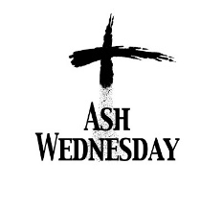
Wednesday, March 6th @ 7:00 pm - Ash Wednesday Service hosted by Casstown Church.

Thursday, April 18th @ 7:00 pm– Maundy Thursday Service - hosted by Bethel UMC

Saturday, April 20th @ noon to 1 pm –Community Easter Egg hunt with the Easter Bunny, crafts, lunch and Egg Hunt at Casstown UMC.

Sunday, April 21st – Easter Morning
7:00 am – Combined Easter Sunrise Service immediately followed by a light breakfast at the Lost Creek Memory Barn. (Wilhelm Barn)
9:00 am – Celebration of the Resurrection worship with communion at Bethel UMC.
10:45 am – Celebration of the Resurrection worship with communion at Casstown UMC.

